

School of Public Administration  
Bachelor of Science in Computing

**COMP491 Final Year Project  
Workbook**Academic Year 2018/19

|  |  |
| --- | --- |
| Pattern Recognition using Machine Learning | |
|  |  |
| Project number: | 20 |
| Student ID: | P-15-0792-1 |
| Student Name: | Zhiming Lin, Tony |
|  |  |
| Supervisor: | Dr. Yue Liu, June |
| Assessor: | Dr. Yang Xu |

# First semester W4-W14

## Week 4

Report Date: 13/9/2018

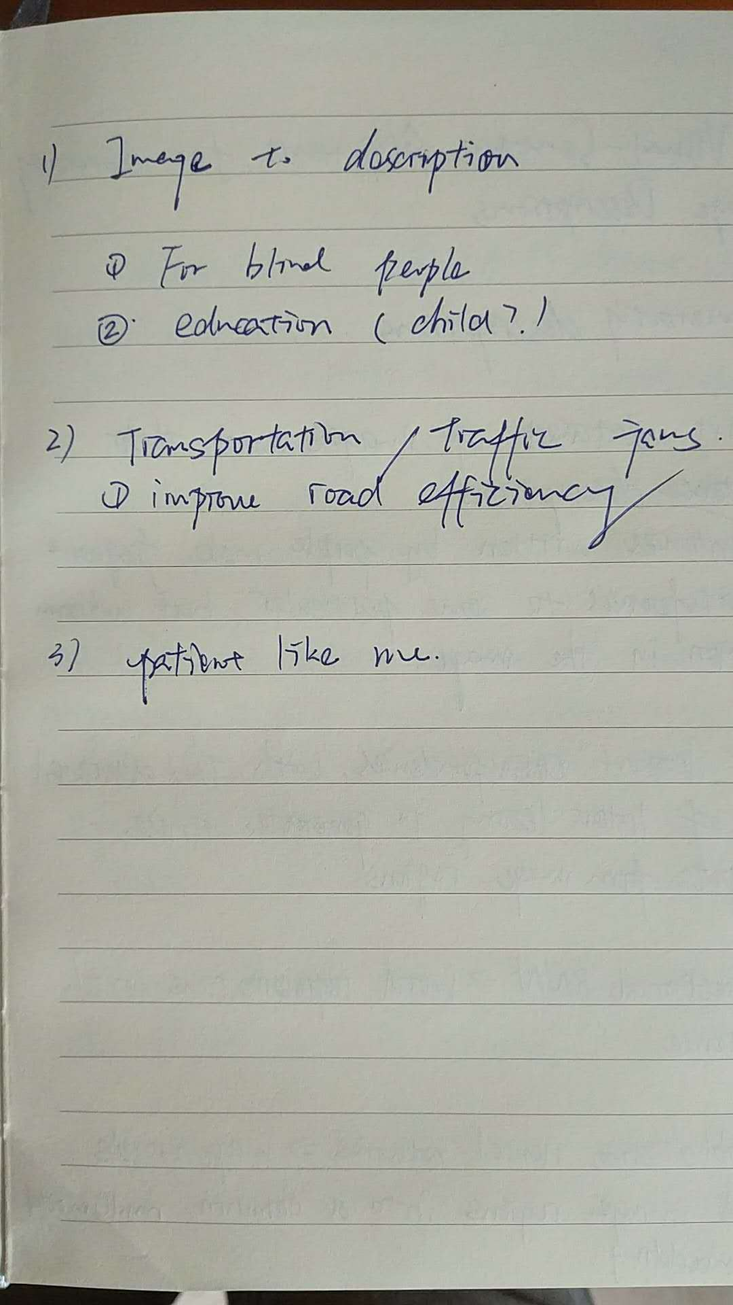

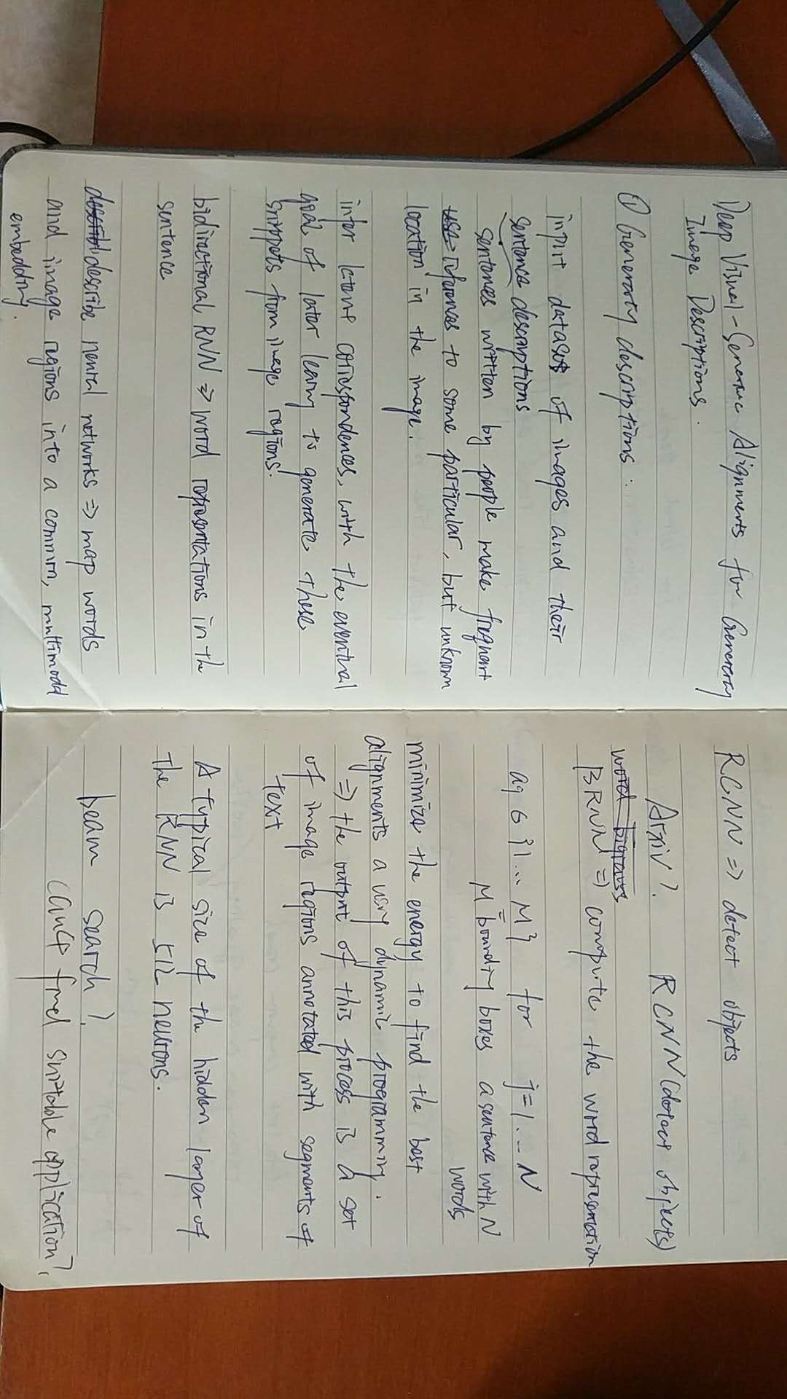

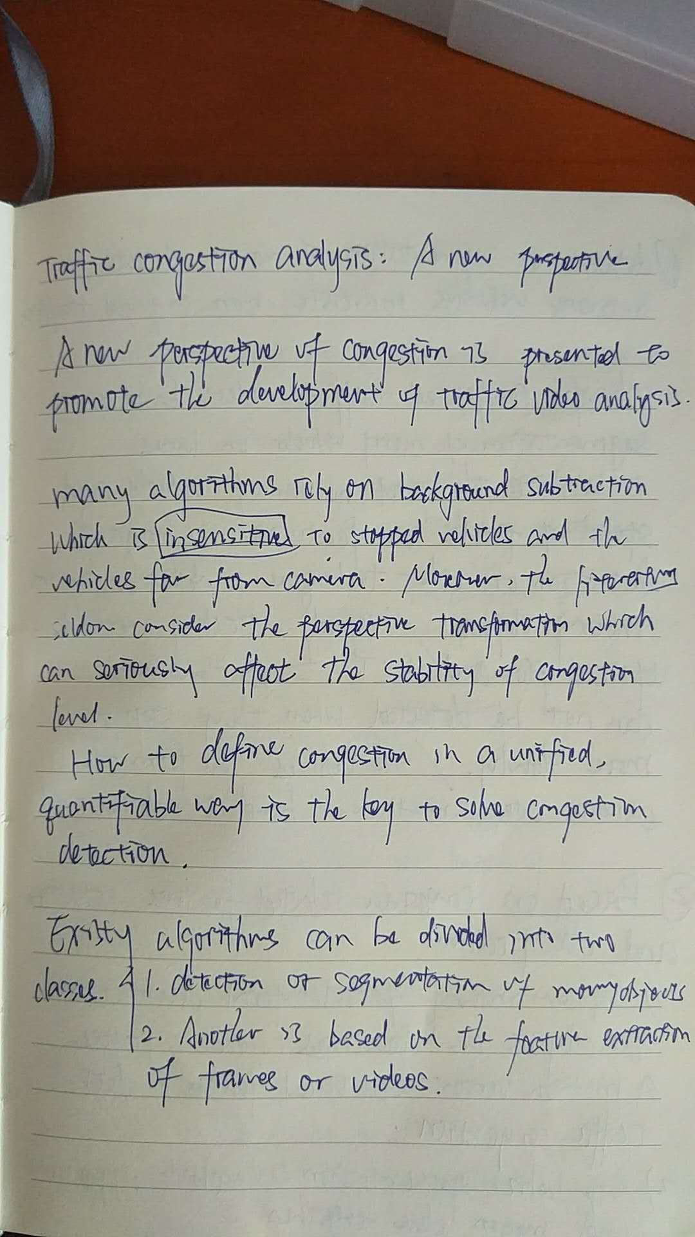

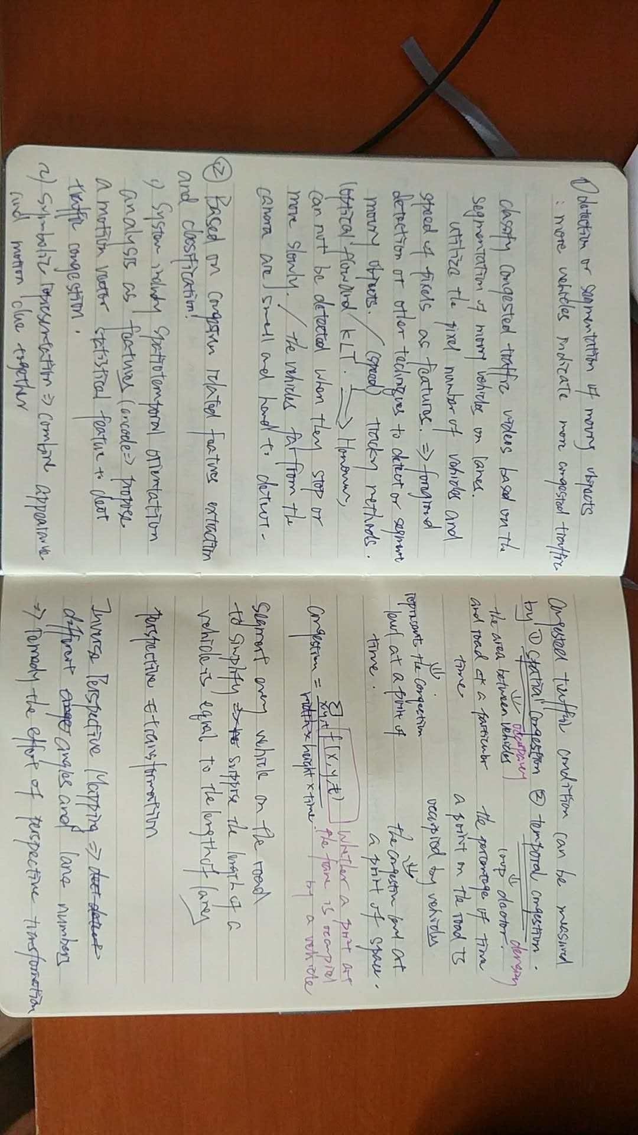

## Week 5

Report Date: 20/9/2018



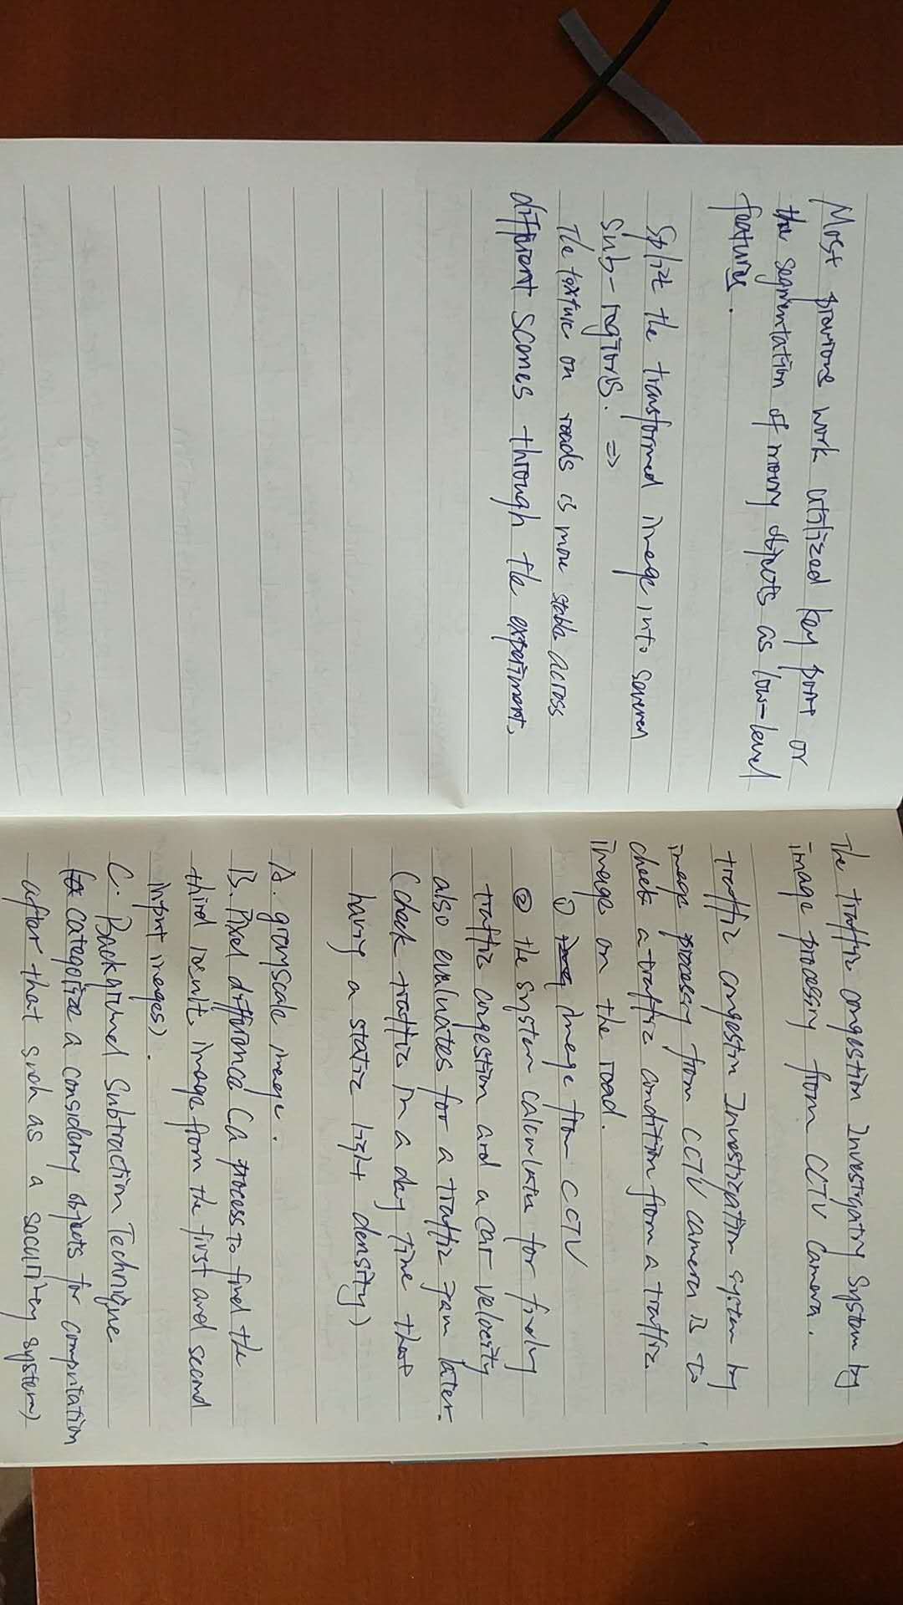

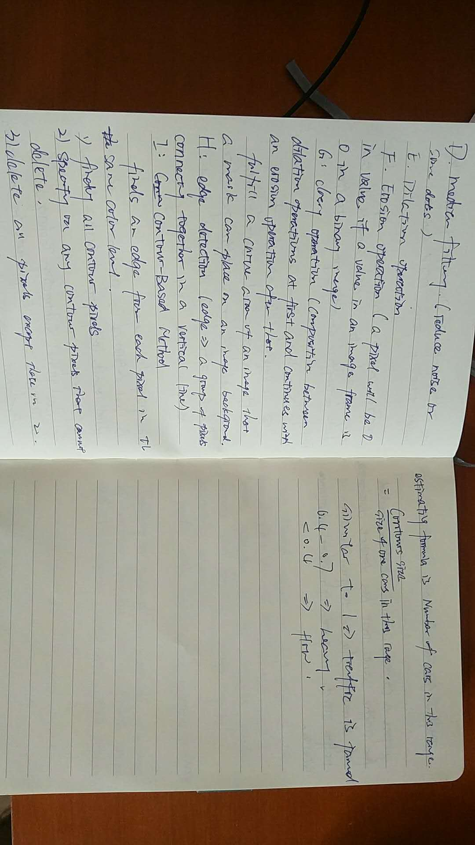

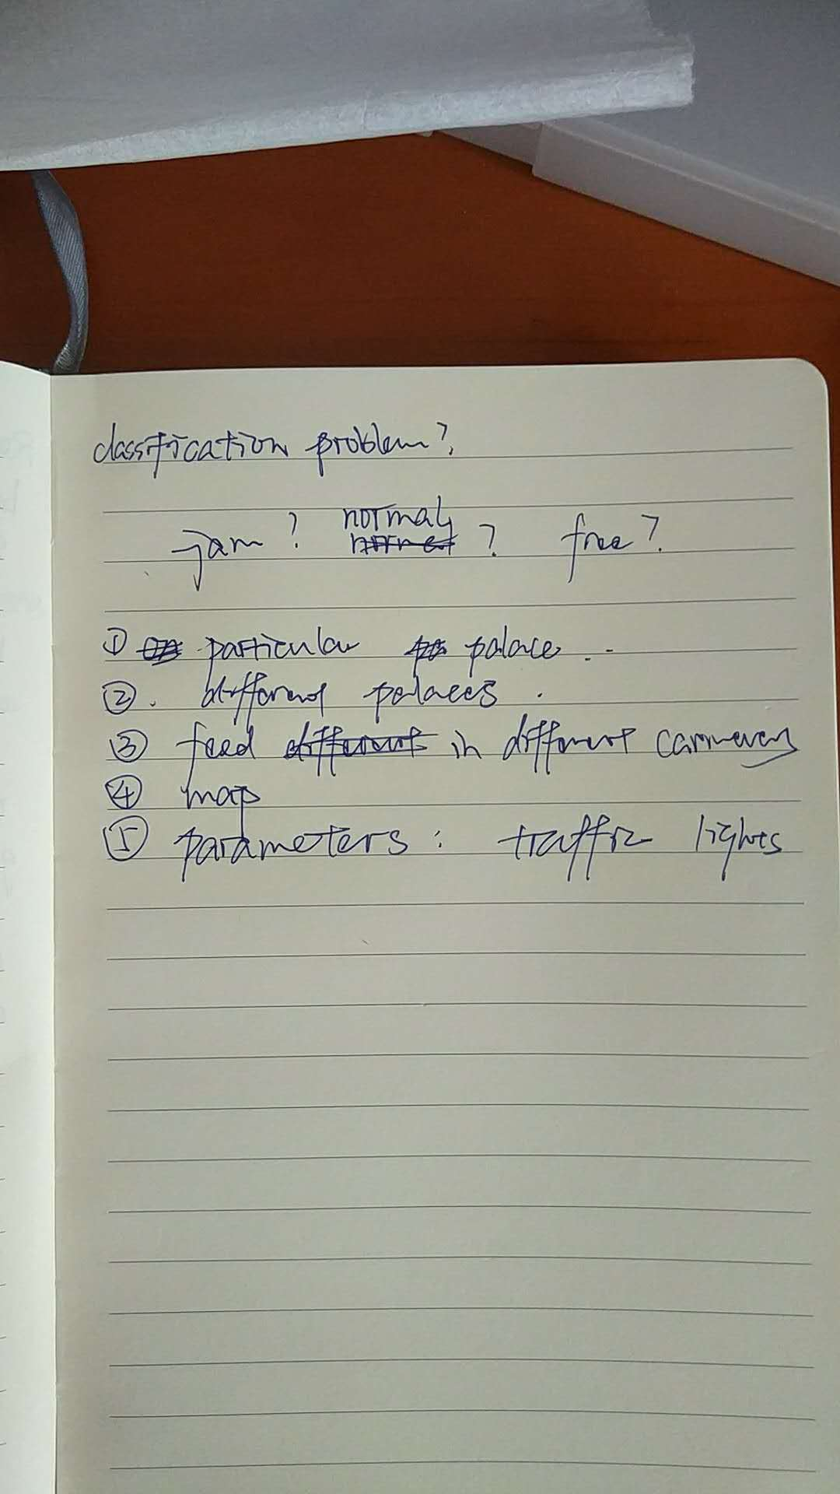

## Week 6 (repeat up to Week 14)

Report Date: dd/mm/yyyy

# Second semester W1-W10

You can add sections for W11 and afterwards if there are still project development notes after W10.

## Week 1

Report Date: dd/mm/yyyy

## Week 2

Report Date: dd/mm/yyyy

## Week 3 (repeat up to Week 10)

Report Date: dd/mm/yyyy